Landing Page of the bus ticket booking system where when clicking on “Book Now” the user will be redirected to Signup/login page.

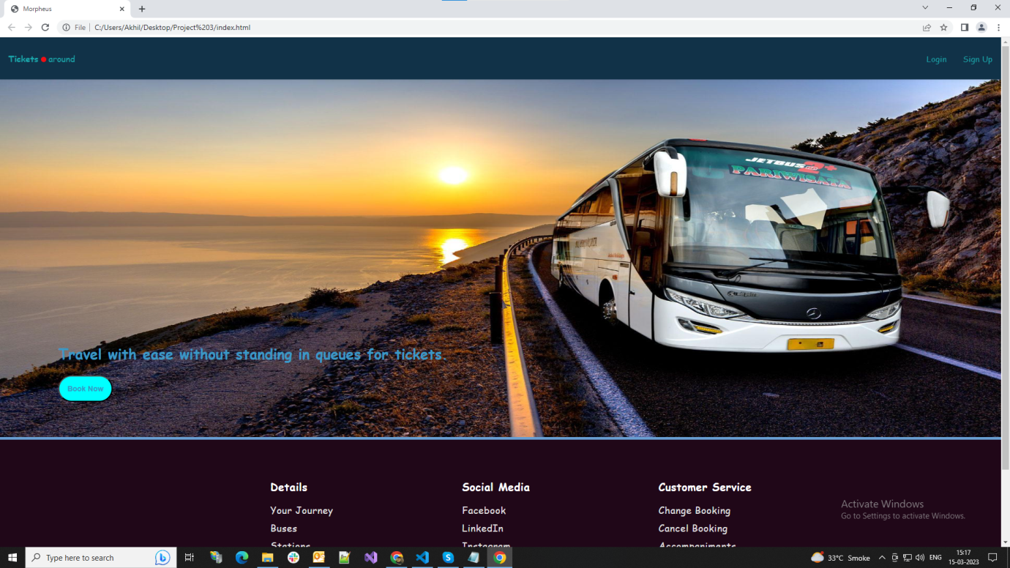

This is the signup/login page in which the signup container is currently visible due to its display style being block while the display style of sign in container is none.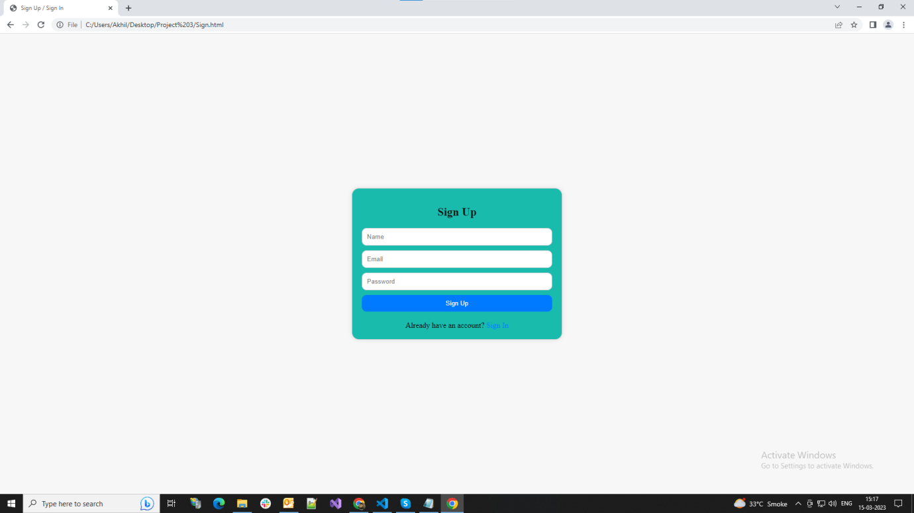This is the sign in container as its display is currently set at block. This is done with javascript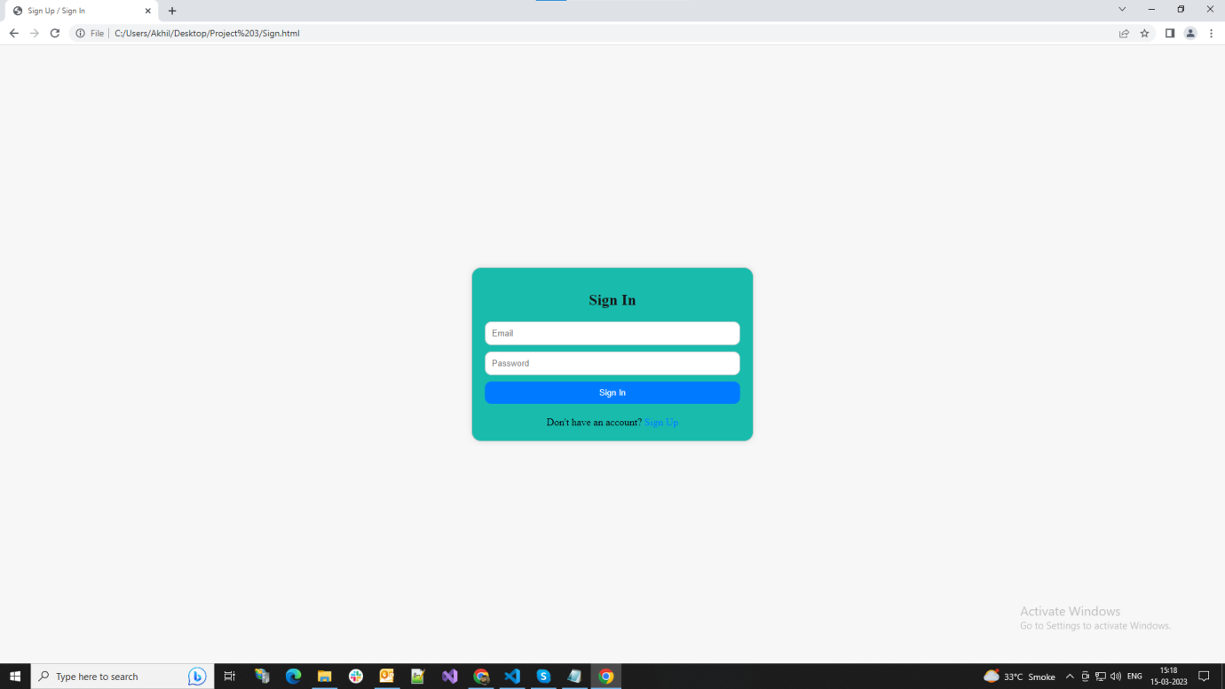

This is the booking page which opens only after a successful sign in. On this page a booking form takes in the required details and submits it for booking on which several conditions are checked like whether the seat which is being booked isn’t already booked or in case a male or female user tries to book a seat next to a booked seat of an opposite gender.

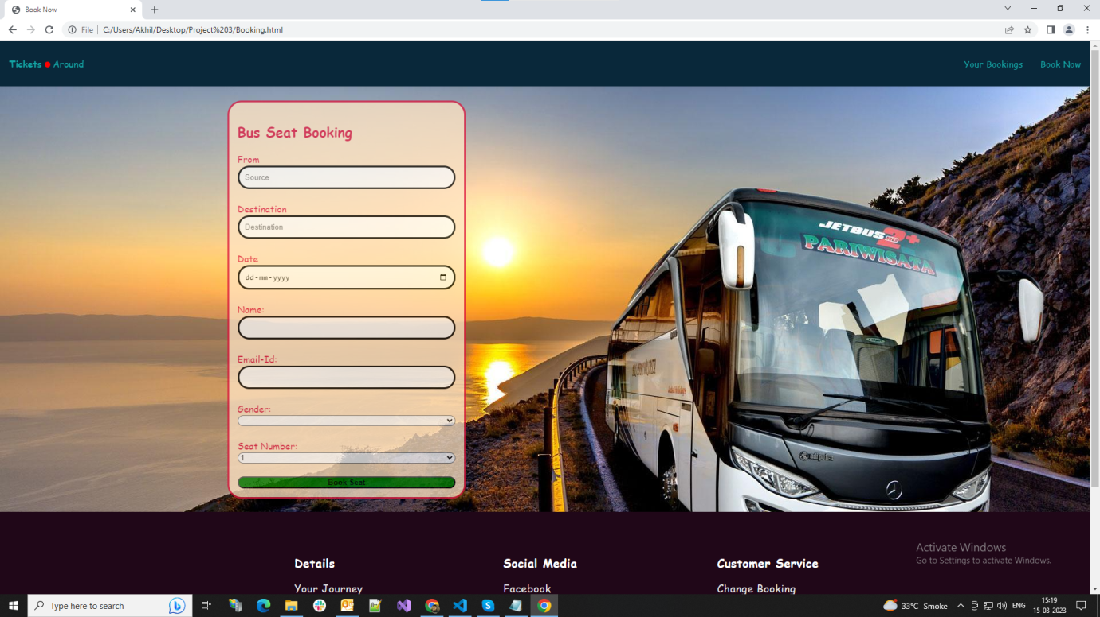

This is where you can see the data being stored in local storage on a successful booking and also the user details are also shown to be stored in local storage.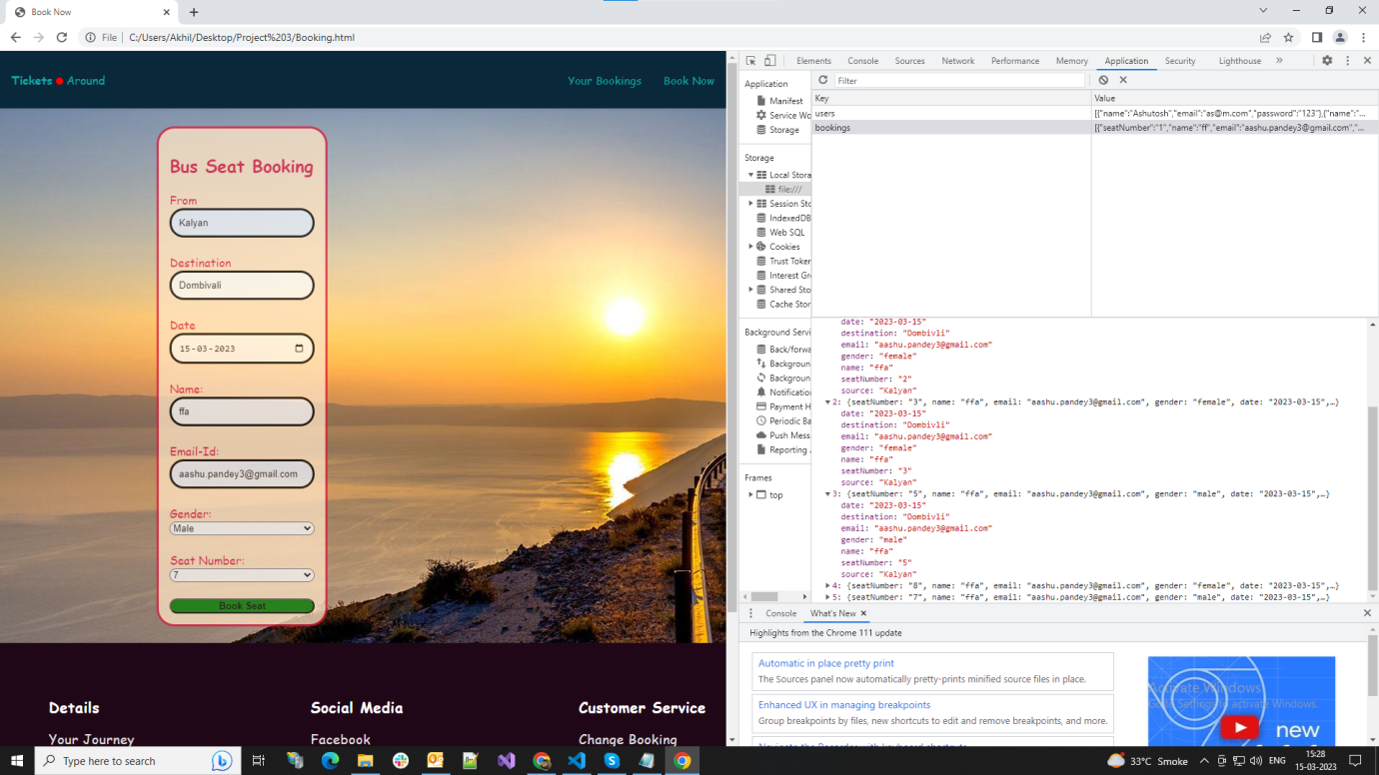

This is where a user can view the booked tickets according to the email id they provided in the booking form.

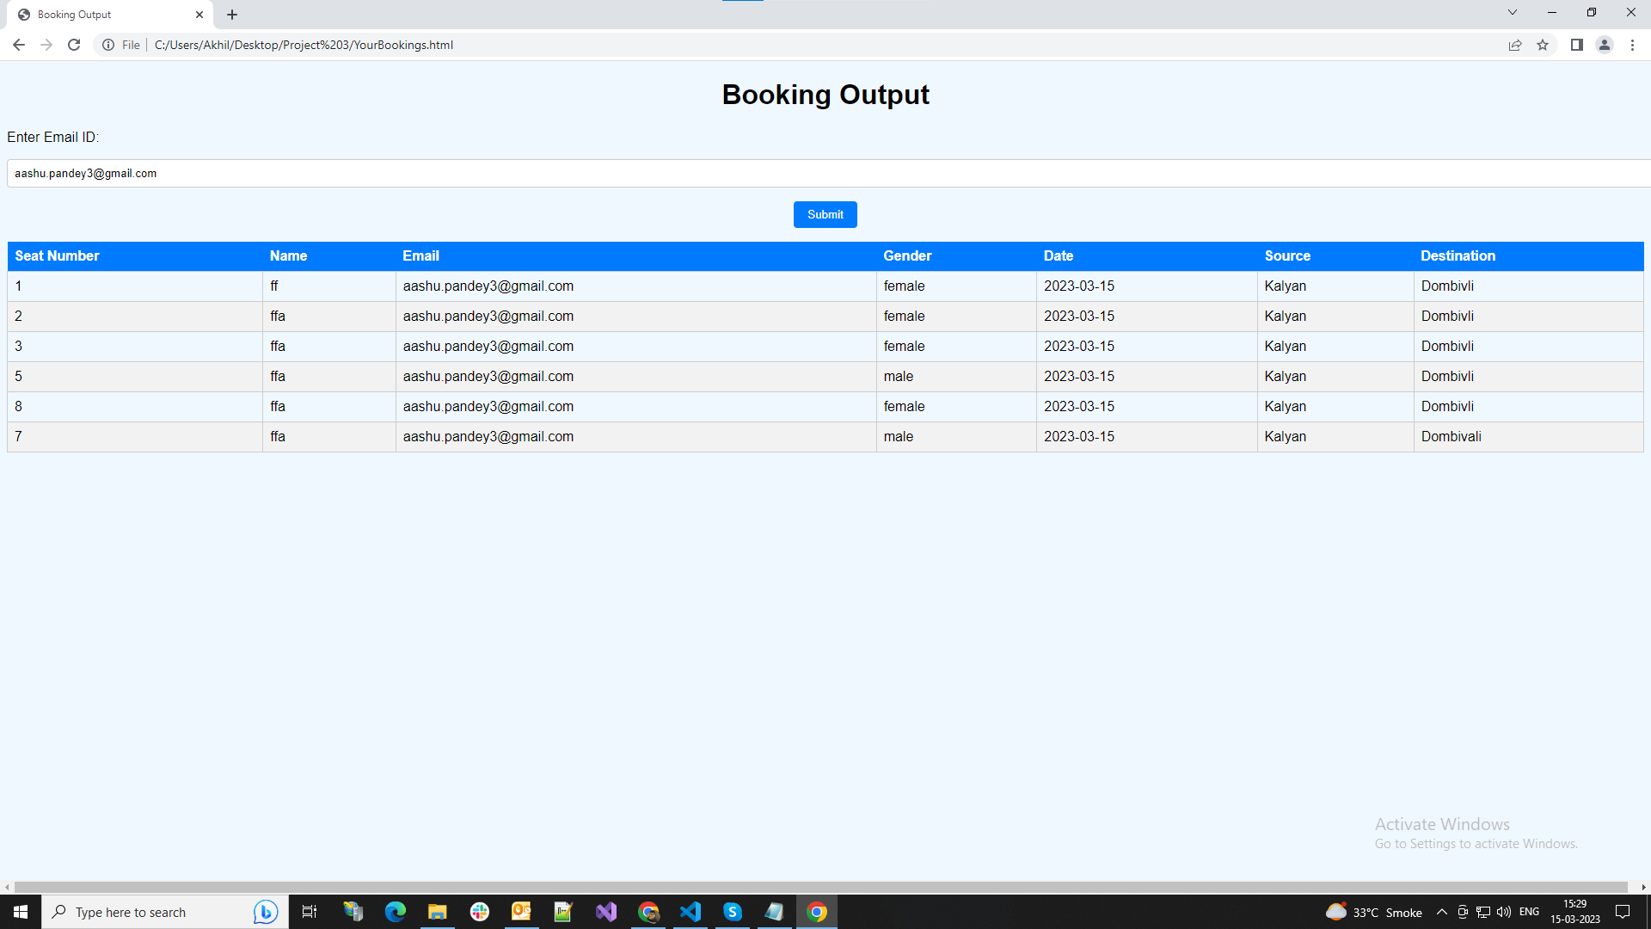

Here the condition of male customer not being able to sit beside female customer.

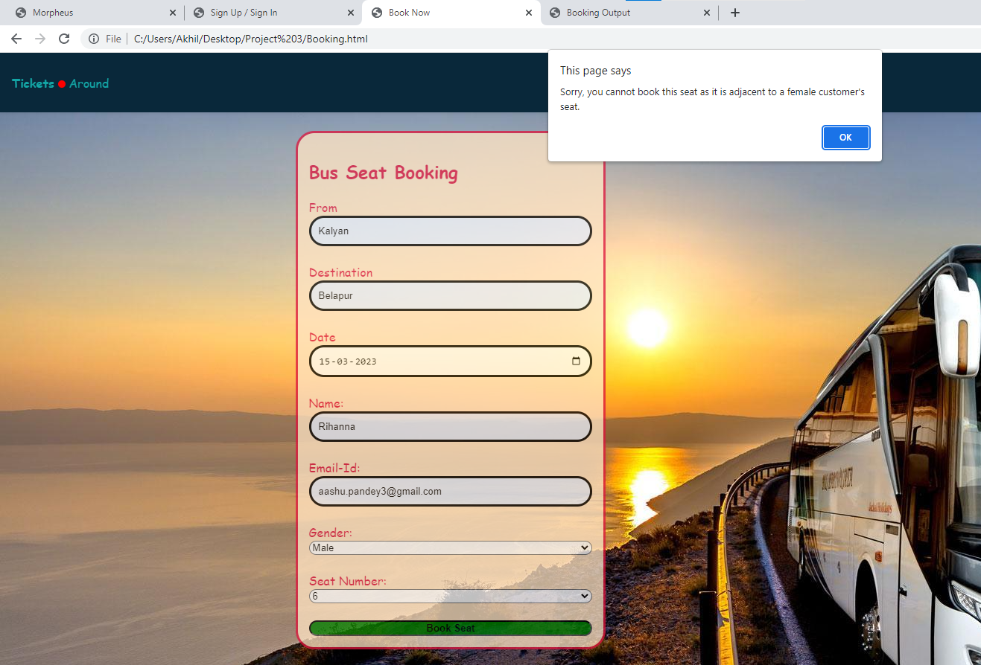

Here the female customer not able to book tickets next to male customer.

